

**PAWSystem**

**IS213 Enterprise Solution Development (AY2019/20 Term 2)**

***G7T3***

**Project Assignment Report**

*Agnes Lam*

*Chantel Er*

*Kong Yu Jie*

*Lee Pei Yi*

*Liu Ming Miao*

*Nicolas Wijaya*

Table of Contents

**1.** **Introduction** 3

**2.** **Technical Overview Diagram** 3

**3.** **User Scenarios** 4

**3.1.** **User Scenario 1 – Customer Manages Booking** 4

**3.1.1.** **Steps Explanation for Scenario 1** 4

**3.1.2.** **Microservices** 4

**3.2.** **User Scenario 2 – Service Provider manage booking** 4

**3.2.1.** **Steps Explanation for Scenario 2** 5

**3.2.2.** **Microservices** 5

**3.3.** **User Scenario 3 – Customer Creates Review** 5

**3.3.1.** **Steps Explanation for Scenario 3** 5

**3.3.2.** **Microservices** 6

**3.4.** **User Scenario 4 – Customer makes Payment** 6

**3.4.1.** **Steps Explanation for Scenario 4** 6

**3.4.2.** **Microservices** 7

**3.4.3.** **Beyond the Labs** 7

**3.5.** **User Scenario 5 – Service Provider Acknowledges Payment** 7

**3.5.1.** **Steps Explanation for Scenario 5** 7

**3.5.2.** **Microservices** 8

**4.** **References** 8

**5.** **Appendices** 8

# **Introduction**

Our team has created a Pet Grooming System called the PAWSystem. PawS System aims to be a one-stop platform for all fragmented pet’s services app in the market. It provides the various functions not limited to the following.

1. Booking Services
2. Payment Service
3. Manage Provider Services

A customer’s journey to using this system to book and proceed to the grooming services will mostly be in 7 steps. It is documented into the workflow as shown below.

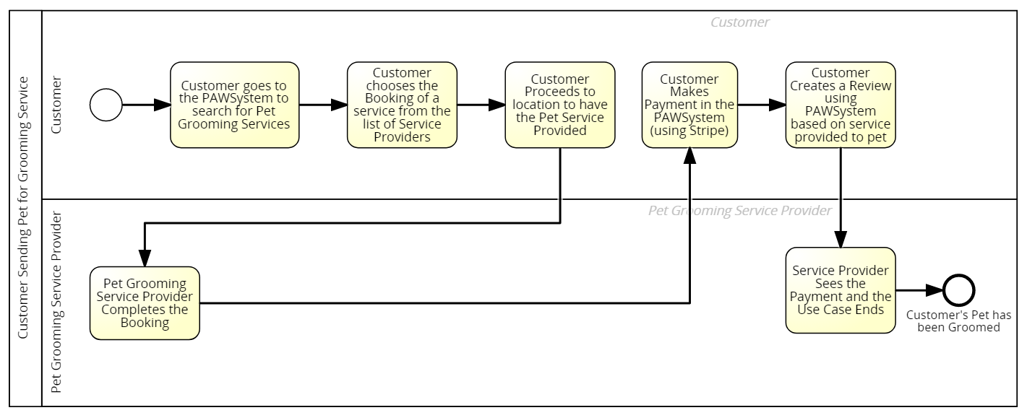

There are two main actors who will be using this scenario, which will then be separated to two User Interfaces.

1. Customer (with pet)
2. Service Provider

For the PAWSystem, our team has implemented 5 user scenarios which consists, but not limited to the following scenarios.

1. Customer manages Booking
2. Service Provider manages Booking
3. Customer creates Review
4. Customer makes Payment
5. Service Provider acknowledges Payment

# **Technical Overview Diagram**

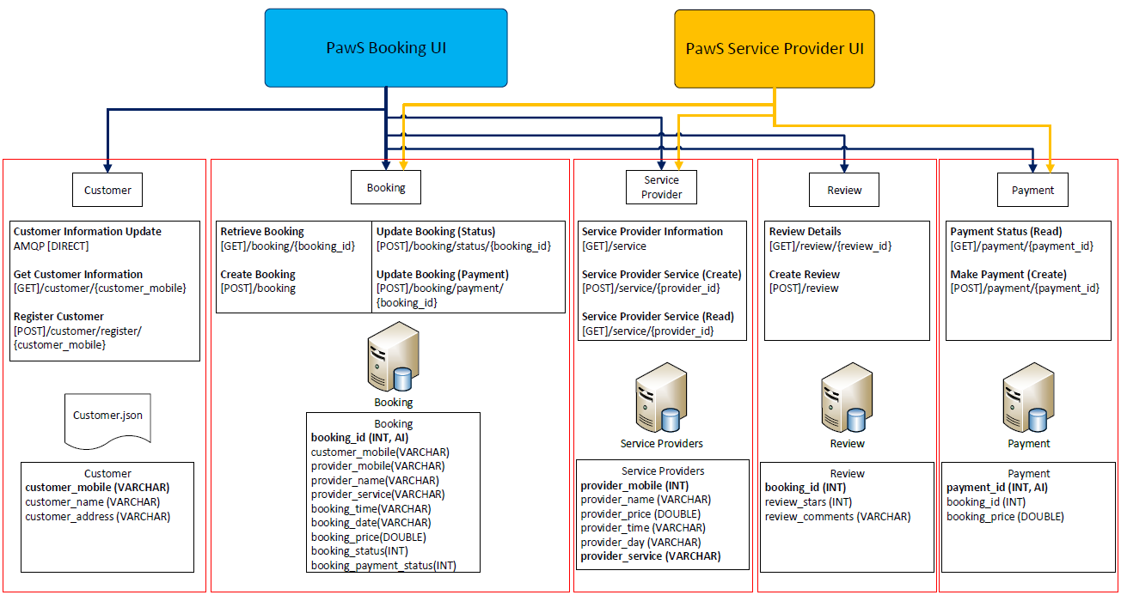

# **User Scenarios**

## **User Scenario 1 – Customer Manages Booking**

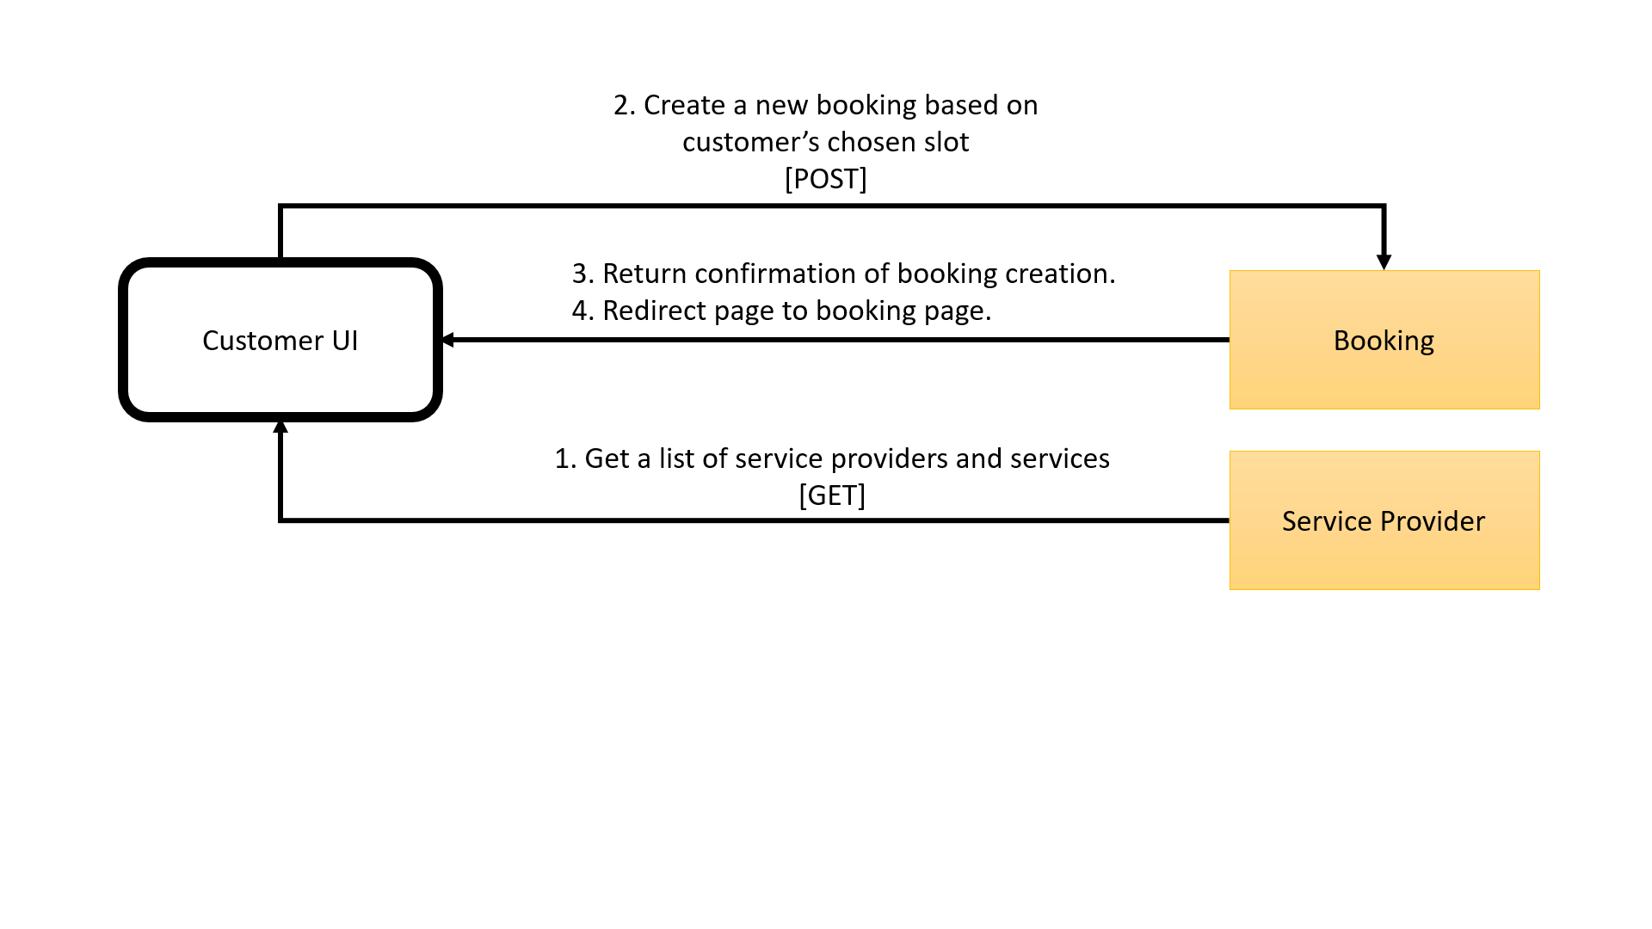

### **Steps Explanation for Scenario 1**

1. Customer will be able to access the list of service providers and their availability and chooses a slot.
2. Upon receiving this UI request, PawS UI then sends a [POST] request to PawS Enterprise Solution book the slot.
3. PawS Enterprise Solution then sends then returns the creation status to the PawS customer UI.
4. The PawS UI then displays the booking page with the new booking’s date and time availability of the service provider to the customer.

### **Microservices**

|  |  |  |  |  |
| --- | --- | --- | --- | --- |
| ***Service Name*** | ***Description of the functionality*** | ***Operational information*** | ***Input (if any)*** | ***Output (if any)*** |
| Service Provider | Get a list of service providers day/time and services provided | HTTP[GET] /serviceprovider | none | [{  provider_day,  provider_mobile,  provider_name,  provider_price,  provider_service,  provider_time  }] |
| Booking | Create new booking for customer | HTTP[POST]/  Booking | {  customer_mobile,  provider_id,  provider_name,  provider_service,  booking_time,  booking_day,  booking_price,  booking_status,  booking_payment_status  } | "Booking Creation Status" |

## **User Scenario 2 – Service Provider manage booking**

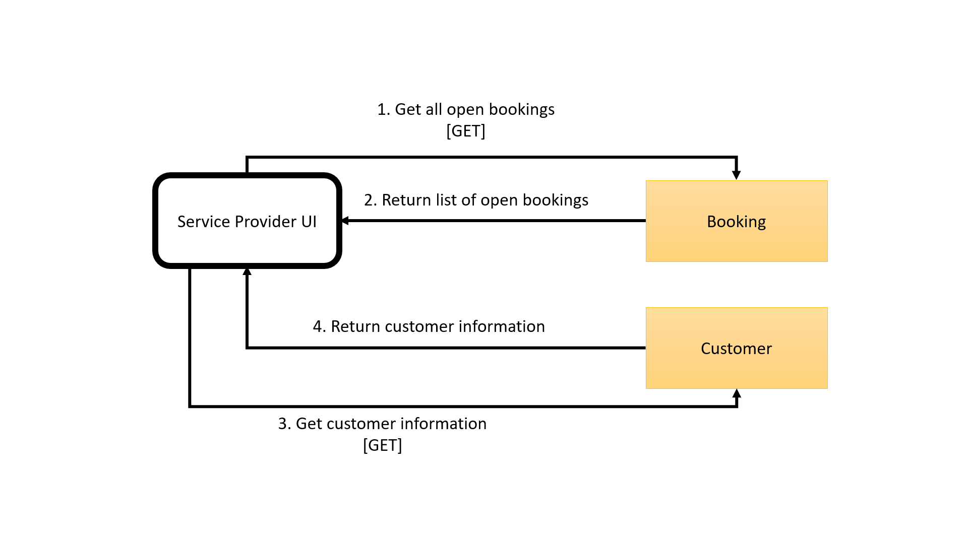

### **Steps Explanation for Scenario 2**

1. Service provider UI will retrieve all the bookings that has been assigned to the merchant via HTTP GET.
2. The Booking microservice will retrieve the information return all the bookings back to the Service Provider UI.
3. The Service Provider UI will also request for the customer information by invoking the Customer microservice using the HTTP GET.
4. The Customer microservice will retrieve the customer information and return it to the Service Provider UI.

### **Microservices**

|  |  |  |  |  |
| --- | --- | --- | --- | --- |
| ***Service Name*** | ***Description of the functionality*** | ***Operational information*** | ***Input (if any)*** | ***Output (if any)*** |
| **Booking** | Get a list of available = bookings | HTTP[GET]  /booking/  <string:provider_id> | {  provider_id  } | [{  customer_mobile,  provider_id,  provider_name,  provider_service,  booking_time,  booking_day,  booking_price,  booking_status,  booking_payment_status  }] |
| Update booking status | HTTP[POST]  /booking/status/  <string:booking_id> | {  booking_id, booking_status  } | "Booking Status Change" |

## **User Scenario 3 – Customer Creates Review**

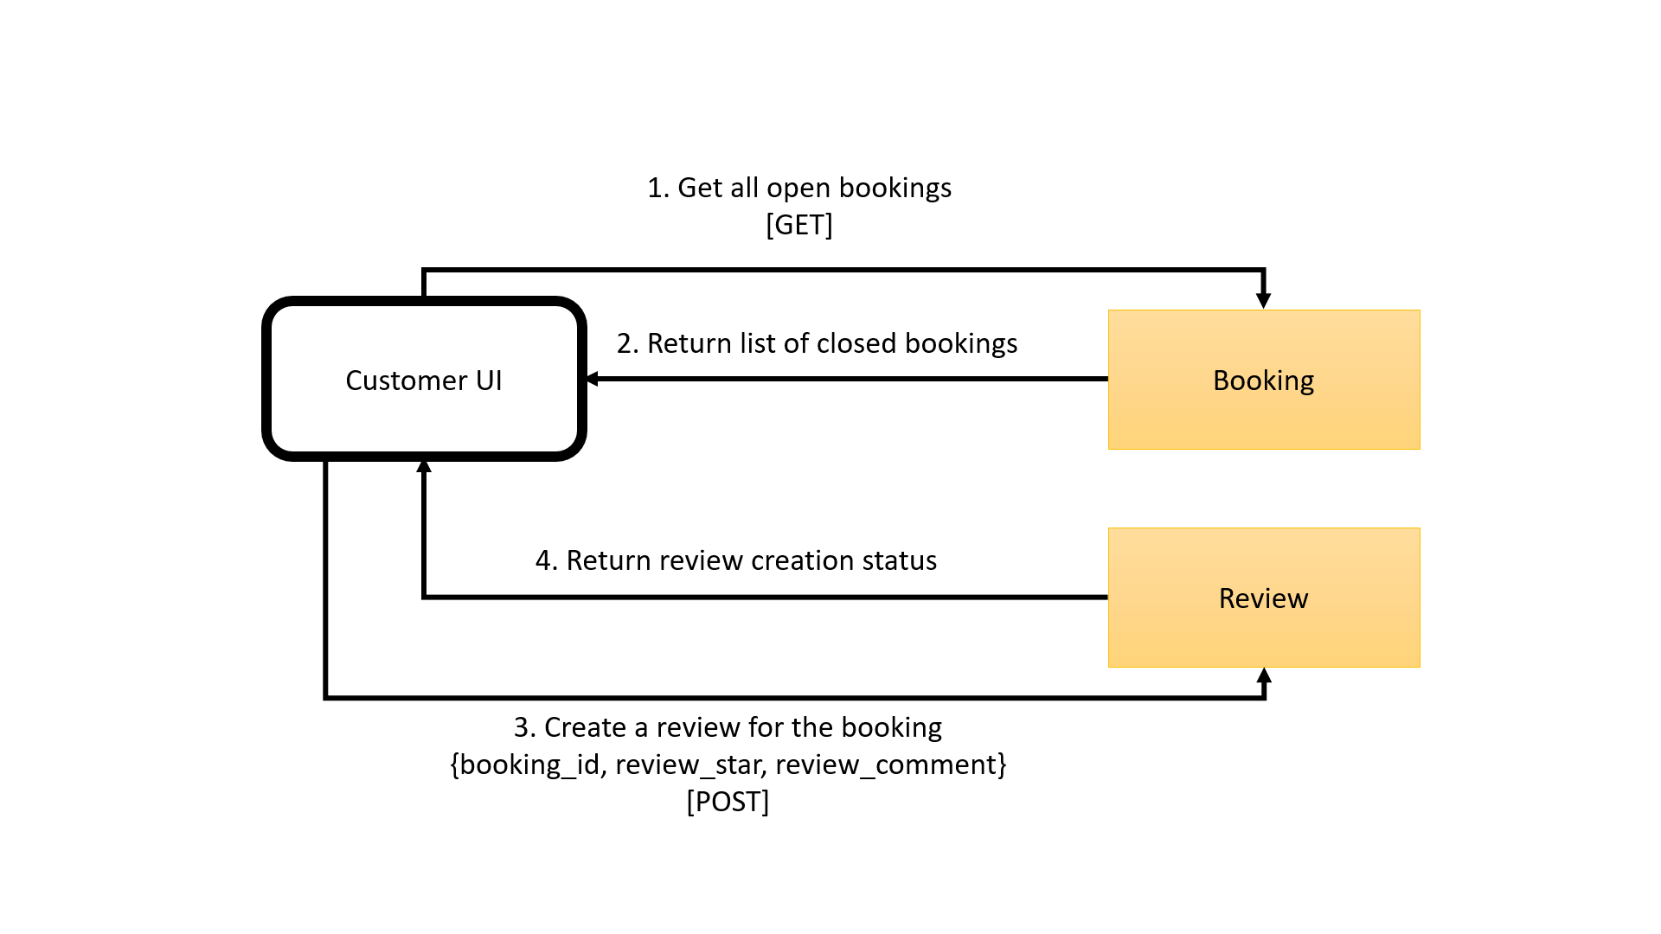

### **Steps Explanation for Scenario 3**

1. The customer will use the UI to invoke the booking microservice to get all bookings via HTTP GET.
2. The Booking microservice will return the list of bookings that have been completed or closed.
3. The customer will write the comments and ratings using the UI and upon submission via HTTP POST, the UI will invoke the Review microservice to create a new record of the review.
4. The Review microservice will return the Review creation status to the UI letting customer know of its status.

### **Microservices**

|  |  |  |  |  |
| --- | --- | --- | --- | --- |
| ***Service Name*** | ***Description of the functionality*** | ***Operational information*** | ***Input (if any)*** | ***Output (if any)*** |
| Review | Customer creates a review based on booking | HTTP[POST]/review/  <string:booking_id> | {  booking_id,  review_star, review_comment  } | "Review Submission Success" |
| Booking | Get list of booking made by customer | HTTP[GET]  /booking/  <string:customer_mobile> | {  customer_mobile  } | [{  customer_mobile,  provider_id,  provider_name,  provider_service,  booking_time,  booking_day,  booking_price,  booking_status,  booking_payment_status  }] |

## **User Scenario 4 – Customer makes Payment**

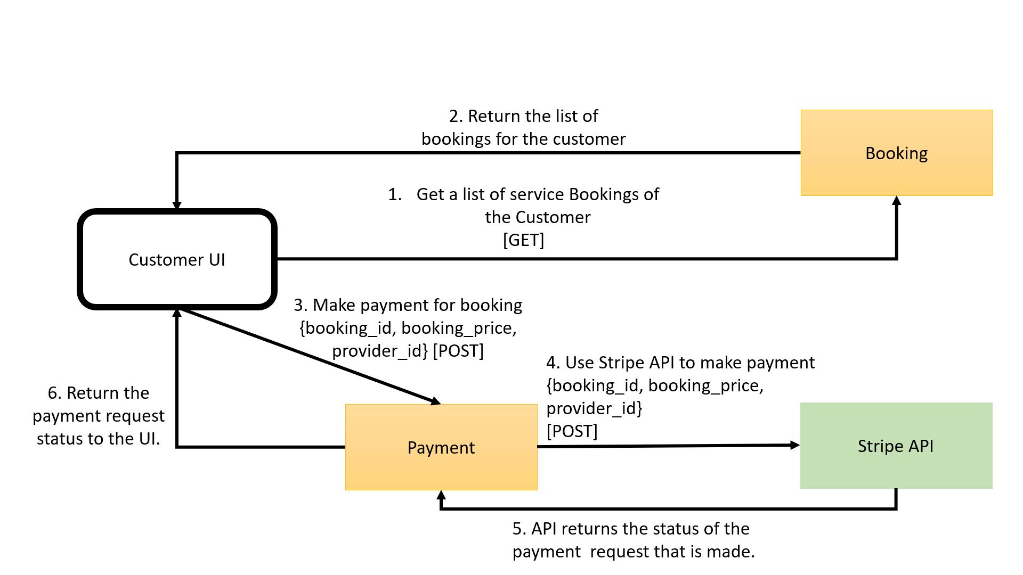

### **Steps Explanation for Scenario 4**

1. The customer uses the customer UI via HTTP GET request message to the booking microservice to get the booking information for the customer’s booking. The customer checks the price of his booking on the Customer UI.
2. The booking microservice returns a reply message consisting of the customer’s booking information.
3. Next, the customer proceeds to make payment on the Customer UI. The Customer UI sends a request message to the external payment service via HTTP POST informing the service about the customer’s payment.
4. The microservice sends a payment request using the Stripe API gateway using HTTP [POST].
5. Stripe API payment then sends back a reply message containing the payment success status.
6. The Customer UI displays the payment status to the UI updates payment status into the payment microservice.

### **Microservices**

|  |  |  |  |  |
| --- | --- | --- | --- | --- |
| ***Service Name*** | ***Description of the functionality*** | ***Operational information*** | ***Input (if any)*** | ***Output (if any)*** |
| *Payment* | *Update booking status* | [POST]/payment/  <string:payment_id> | {  payment_id,  booking_id,  booking_price,  provider_id  } | "Update Status" |
| *Stripe Payment API* | *Validating payments* | Charge.php will [POST] to the Stripe’s DB | {  first_name, last_name,  card_number,  payment_amount  } | "Payment process status" |
| Booking | Get list of booking made by customer | HTTP[GET]/customer/  <string:customer_mobile> | {  customer_mobile  } | [{  customer_mobile,  provider_id,  provider_name,  provider_service,  booking_time,  booking_day,  booking_price,  booking_status,  booking_payment_status  }] |

### **Beyond the Labs**

* + - 1. **Stripe API**In this portion, the Stripe API has been used to do the payment of each customer. The Stripe API is organized around REST. Upon user payment and confirmation, it sends the data from the webpage via the HTTP POST method and passes the information of the transaction in the JSON data format. The information is saved in the Stripe account holders’ database.

On top of that, this transaction is also captured into the payment microservice database table so that the merchant, in this case, the service provider can check whether the payment has been made for the service provided. This will be mentioned in part 3.5.

## **User Scenario 5 – Service Provider Acknowledges Payment**

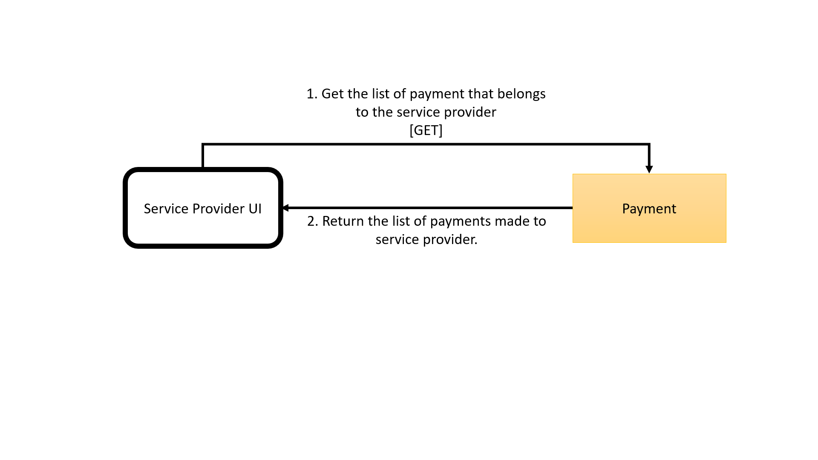

### **Steps Explanation for Scenario 5**

1. The service provider logs in and the UI will invoke the payment microservice to retrieve all payments that have been successfully made for the service provider via HTTP GET.
2. The microservice will retrieve the request and returns to the Service Provider UI to be reflected to user.

### **Microservices**

|  |  |  |  |  |
| --- | --- | --- | --- | --- |
| ***Service Name*** | ***Description of the functionality*** | ***Operational information*** | ***Input (if any)*** | ***Output (if any)*** |
| Payment | Get list of payments made to the service provider | HTTP[GET]/payment/provider/  <string:provider_id> | {provider_id} | {  payment_id,  booking_id,  booking_price, } |

# **References**

* 1. Stripe. (n.d.). Stripe API Reference. Retrieved from <https://stripe.com/docs/api>
  2. jQuery and Javascript Plugins. Retrieved from
     1. <https://stackpath.bootstrapcdn.com/bootstrap/4.2.1/css/bootstrap.min.css>
     2. <https://ajax.googleapis.com/ajax/libs/jquery/3.4.1/jquery.min.js>
     3. <https://cdnjs.cloudflare.com/ajax/libs/popper.js/1.14.6/umd/popper.min.js>
     4. <https://stackpath.bootstrapcdn.com/bootstrap/4.2.1/js/bootstrap.min.js>

# **Appendices**

* 1. Technical Overview Diagram



* 1. Customer Sends Pet for Grooming Services Process

